Creative Interactive Activities
- How they might fit at The McWane Center
- Career Advice

Meeting with….

Lamar Smith
Vice President of Exhibits & Planning
The McWane Center
714-8395
3-23-06

Lisa Schwaiger
studentLisa@hotmail.com
205-836-5247

The Creative Zoo --
A zoo where the exhibits are creative people
and there's lots of interactivity.
Vision Statement: The Creative Zoo is where regular people (re)discover and delight in their own creativity.
Mission Statement: By making the creative process available to view and study, the visitor's own creativity is stimulated and released. So many people have forgotten that EVERYone is creative, and so much personal joy can come from the process of creating. Plus a world filled with people in touch with their creative side and exploring their creative potential is a world more flexible and adaptable to whatever may come and more delightful and fun to live in.
The Creative Zoo (TCZ) is a unique entertainment venue that blends some of the most appealing aspects of zoos, theme parks, and art and science museums, as well as carnival midways, roadside attractions, and even summer camps. TCZ is not for the passive observer, but for people of all ages and backgrounds who crave a fun, stimulating, and fully interactive experience that allows them to get in touch with their own creativity in ways they never dreamed possible. It is a place where visitors -- including couples, groups of friends, and entire families -- can discover hidden talents and interact with each other in delightful new ways through a myriad of games, exhibits, and creative activities.
TCZ has two areas:
- The centerpiece of TCZ is a series of unique and visually arresting exhibition spaces in which professional creators, including writers, musicians, and visual artists, are themselves the exhibits. Visitors watch the creators as they work, interact with the creators in various unobtrusive ways, and gain a unique view of the creative process.
- TCZ also features dozens of creative interactive activities, or CIAs (in fact, over a hundred of these activities have been conceived so far). During the course of a day, a visitor might finger paint, create a piece of art using her own body, join with others to make a giant chalk drawing, write and perform a radio drama, participate in structured insulting, get and give creative career advice, compete for a best joke award, join a round of comedy improv, enjoy an artistic mini-golf course, have her dream from last night brought to life on stage, see a locally made movie, contemplate the meaning of her own life, walk a mile in someone else's shoes (literally), help perform music, and eat with an artist. And when she's tired, she can sit in her choice of whimsical seats and enjoy something from the Creative Juices Bar.
It should be emphasized that a CIA would not be, for example, an acting or painting or sculpture class. TCZ is not a place to acquire skills in a traditional sense. Instead, a visitor is encouraged to fully immerse himself in a variety of creative activities, which immediately reward him with fun experiences and perhaps even keepsakes -- such as photographs or CDs that record his creative experience.
Me & My pitch to you today….

I’ve enjoyed science-type/hands-on museums in Seattle, Portland, Washington DC, Charlotte and here. I enjoy fun/whimsical creativity, design and problem-solving. My educational background is advertising, psychology, statistics, and computer technology.
Some interesting (diverse) facts about me are:
- I started a group in Seattle called “The Advice People” – for years, we sold advice to passers-by and, from that, got hired to host one of the first Internet Radio shows in history.
- I conceptualized, wrote, directed and edited several TV shows in Seattle.
- I organized, fund-raised and hosted a street dance.
- I got a perfect 800 score on my math SATs and was a National Merit Scholar.
- I’ve created imaginative and award-winning Halloween costumes.
- I host quit smoking support groups, and I’ve taken ballroom dance lessons.
- I entertained a young boy for hours with “Urban Fishing” – putting a fishing pole out my 3rd story apartment window with a sign at the “bait-end” asking pedestrians to put something interesting on the hook.

I’ve been steadily employed as a secretary for years but desire a career change that allows my creative side to flourish and be challenged. I don’t have any traditional “talents” – can’t draw or play music, but I definitely feel like a very creative person. In my vision, TCZ appeals to people like me -- who enjoy the feeling of creating or novelty, but who don’t ordinarily think of themselves as having much in common with “artists”.

One of the aspects of The Creative Zoo is “CIA”s (Creative Interactive Activities) – activities that let “average” people feel and be creative and see their friends/family behaving creatively. I have a list of over 100 CIA’s (and more ideas just keep coming). I feel absolutely compelled to do something with these ideas.

I can see ….
- some of these CIAs incorporated into The McWane Center because some have scientific elements in them, and/or
- a separate “creative” section at The McWane Center (or at a different location under management of McWane) that focuses on the creative more than the scientific.

After my most recent visit to The McWane Center, I developed the following 4 clusters that I think would be appropriate and feasible for The McWane Center:

TEASERS/ADS FOR THE CLUSTERS:
- Use hexadecimal numbers to create millions of colors. Compete with your friends to see who can make a specific color the fastest or just find your own favorite color. Learn how to make your own basic web page.
- Pose as a doctor or a nurse, diagnose patients, interpret “doctor talk” into English, find your internal organs, broadcast your heart beat, smell (if you dare) various bodily fluids.
- Be a test subject in a fun, long-running scientific experiment – we’ll surprise you how. (Boring note for adults: actual participation in a scientific experiment reinforces the principals of the scientific method)
- Mirrors and Videos -- Be the human in a Human Kaleidoscope (while learning about angles), marvel at your 6-foot-tall head, lace your face with your friend’s face for a cheap laugh, and take the fascinating “more or less attractive” test.
Components / Details of Cluster #1 -- “Colors, Colors Everywhere”

Consists of  - 2 sets of ….  - 3 giant (or 6 more normal sized) slider- controls on the floor or on a table-top  - a display screen  - A siren/flashing light to indicate correct | Example Screen…
  FF FF 00
  FF 00 00
Top Half of the Screen:  - Always shows the color represented by the location of the 3 sliders - which represent Red, Green, and Blue (as in how computers use RGB values to represent colors).  - As the sliders get moved, the value of all sliders (i.e., 13, A7, DD) are displayed on top of the actual color | 

Difficulty Levels
everybody | Just move the sliders at random to see what colors you get.
older kids, some adults | Bottom half of screen shows a random color (with its RGB value like "D2 69 1E").  When Visitor matches it (on top part of screen), siren/flashing light to congratulate.  And then it changes to another random selection.  (2 visitors can compete against each other to see who gets it first.)
most adults, some older kids | Bottom half of screen shows a random color (without its RGB value).  When Visitor matches it (on top part of screen), sirens/flashing light to congratulate.  And then it changes to another random selection.  (2 visitors can compete against each other to see who gets it first.)
Other parts of the display…
What Visitors see / interact with | Why? / Explains what? / Details
Flip Charts / Display | Explaining base 2 vs base 10
Oversized hands (2 sets):  - One (with 10 fingers) has regular decimal numbers on the finger tips  - One (with 16 fingers) has hexidecimal numbers on the finger tips | Decimal vs hexadecimal
4 (8) on/off lights | To show how 16 (256) can be represented in computers using only 4 (8) lights
Display Board:  “How many different colors are possible with RBG?”  Can flip up a board to see the Hint: "What is 256x256x256?"  Magic Erase Board or oversized calculator.  Type in your answer on a key pad. If correct, sirens go off, if not you hear “higher” or “lower”. | Show how many colors are possible with the RGB system.
Various Tiles of similar colors with RGBs values on back.  Display Board: “Are these colors the same?” | Explores how many different colors the eye can distinguish?
Slips of paper where Visitor can write an RGB value that he likes.  Typed out already on the paper is the html code and instructions for how to (at home) make a simple html web page where the favorite color is the background. | In a text document, type  <HTML><BODY BGCOLOR = "#______________"><font size = 7>I love the McWane Center.  Save as "mcwane.htm” on your desktop. Then click on it to open

Some possible extra stuff:
- Scanner / reader. Could have a reader that takes a color (skin, article of clothing) from a Visitor and interprets it to a RGB value
- Display about colors – For examples… What emotional responses various colors provoke, like red is alertness --Why? Why are people “green with envy”?
- How rods and cones in the eye work

Components / Details of Cluster #2 -- “Medical Cluster”

Mr. Organs  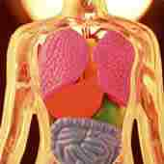 | A full-sized mannequin (or torso) with exposed organs (no skin). (If it’s a full mannequin, he has a speedo or swim trunks on that say something like "rated G".)  Visitor uses a stethoscope-type apparatus (with headphones) to interact with this exhibit. The stethoscope has 3 level settings: "kid", "young adult" and "adult" -- each with a different level of sophistication in terms of explanation.  When the Visitor places the scope on an organ, she hears explanation of that organ: heart, lungs, appendix, liver, spleen, pancreas, kidney, gall bladder. For example, “kid” level on heart says "I'm a heart. I pump the blood in your body."
Diagnosis  John, age 57  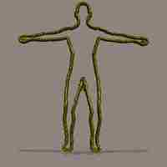 | Part 1…  Have Outlines of patients (ideally these are real patient cases), and their names and ages ("John, age 57”, "Sandy, age 11”). (The Outlines are in a seated position so kids can easily reach mouth, the chairs are mutely-painted on wall in background.) Each Outline is a different basic color.  - Press the button (where the Outline's mouth would be) to hear (in real patient's voice) the presenting symptoms.  - If fever, Visitor can place hand on forehead and feel the heat  - Could lift a panel and see the heartbeat (video monitor) or feel the pulse on wrist  - Lift the panel on the chest, and see the chest xray, etc, etc, etc  Part 2  Across from the patients, there is a mural on the wall of a kindly doctor sitting behind his desk (diplomas behind him). Sticking out of the wall is a private speaker that Visitor puts her ear beside. Visitor uses a slider or dial to select which patient she’s interested in. Then she presses one of several buttons to hear doctor's voice:  *Hear process used to determine diagnosis *Hear the diagnosis *Hear prognosis  *Hear how patient is actually doing now (in doctor's and patient's voice)
Latin Wheels / “Doctor Speak” | Two upright wheels (like on the Price is Right).  Each with Latin prefixes/suffixes (and what they mean). Visitors turn the wheels until it forms a word that means something, for example when “nephr” lines up with “ology”, Visitor presses a button and hears “Nephrology is branch of medicine concerned with the kidneys”
When I Grow Up I want to be a Nurse / Doctor | - Have Nurse/Doctor outfits that Velcro on back – multiple kid sizes and adult sizes  - Have several patient-mannequins (including one in surgery) and props that Visitors can use: like bandage, a pen-light, a fake stethoscope, a fake syringe, a thermometer, a blood pressure cup, patient chart, drip bag, fake surgery tools.  For $2, a volunteer will take Visitor’s picture and agree to email or mail Visitor the photo in a nice displayable format (see example). Visitor also gets $2 off coupon for a “When I Grow Up I Want To Be a Nurse” DVD available in the gift shop.
  When I grow up…  ….I want to be a nurse | What I can do as a young person to prepare to be a nurse:  - Take lots of science classes.  - Volunteer at the hospital  - Nurse my sick family members  - Memorize all 218 bones  - Ask people how they feel  - Learn some Latin
Heartbeat | A stethoscope that Visitors can put on their chest or wrist that broadcasts their heartbeat out loud. (Could have box of tissues that Visitors can put between the cup part of the stethoscope and their skin if concerns about communicable disease.) I think little kids would really dig this.
Smelly | With fair warning, could also have pictures of gross diseased parts and bodily excretions - appropriately encased. Maybe could have a "Turn here to smell… if you dare" option.
Notes | - Could sell shirts showing organs (in different sizes) in gift shop  - Could be sponsored by a hospital - maybe Children's Hospital -- or a medical school  - Good cross promotion with a “When I Grow Up” DVD series.

Components / Details of Cluster #3 -- “Scientific Method”

This really shows two ideas:
- The power of suggestion and
- The Scientific Method.
It’s a simple throw-the-ball-thru-a-hoop exercise, with the results tabulated automatically.
The participant goes inside a private room with 3 balls and a hoop. He is randomly (secretly) assigned to one of three groups and he then hears (or sees) the rules: “The goal is to throw each ball though the hoop.”
- If he’s Group A, that’s all he hears.
- If he’s Group B, he also hears “This is very easy and most people get all 3".
- If he’s Group C, he also hears “This is very hard and most people don’t get any."

After his throws, he gets to see the running tab of hits/misses of each group:

Group | A | B | C | Total
Hits | 16 | 22 | 14 | 52
Misses | 29 | 25 | 30 | 84
Total | 45 | 47 | 44 | 136
Percentage Hits | 36% | 47% | 32% | 38%

And he sees/hears an explanation of hypotheses, control group, and randomization (as well as a separate display about "the power of suggestion").
Components / Details of Cluster #4 -- “Mirrors and Video”

Human Kaleidoscope  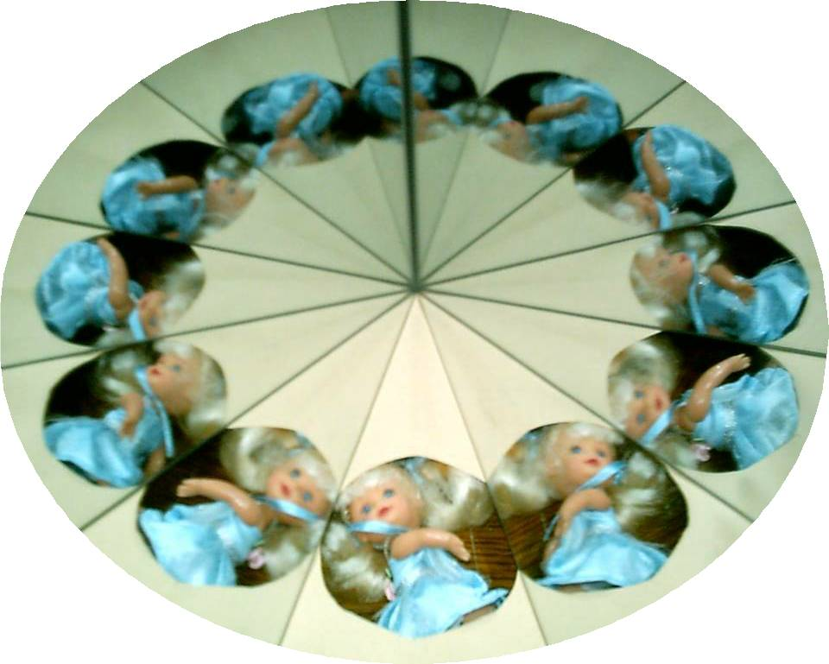  - Display Board with flip up answers,  - a calculator  - a magic erase board  - a small Rosetta Kaleidoscope (with adjustable mirrors) – like photo below -- and angle measuring devise  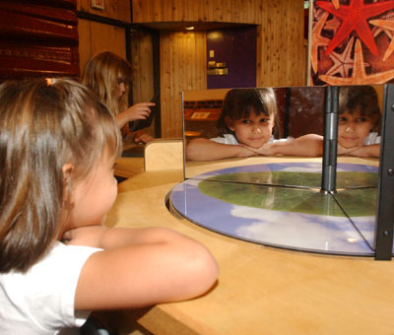 | Using a viewing hole, and 2 mirrors inside a large clear tube and some pulleys to turn the tube, you have a Human Kaleidoscope.  This can appeal on different levels.  - Everybody can enjoy posing as the “human”, and viewing the images  - Adults enjoy videotaping or taking photos of their kids.  - Kids enjoy moving the cylinder around with the pullies (can also teach a lesson about pullies).  - Older kids will like the angles experiments.  Display Boards say….  “Easy: How many of the same image do you see?” [flip to see 12]  “Easy: How many degrees are in a circle?” [flip to see 360]  “Hard: At what degree angles are the mirrors set?” [flip to see “30 (360/12)”]  “Harder: If you wanted 10 images, at what degree angle should you set the mirrors?” [flip to see “36”]  “Harder: If the mirrors were set at 45 degree angle how many images would you see?” [flip to see “8”]  Hardest:  - Using paper and pen, graph the 3 points on the graph you determined in earlier questions.  - Use the ruler to draw a line through those points  - Answer these questions using your graph:  - If you saw 24 images what degree angle would the mirrors be at?  - If the mirrors were at 60 degrees angles, how many images would you see?  - Test it out on the Rosetta kaleidoscope.  Notes:  - The graph paper could be provided by “Sylvan Learning” or a competitor of Sylvan for a fee. They could sponsor the whole exhibit.  - Other science museums have somewhat similar installations called “Walk In” Kaleidoscope
6-foot tall face  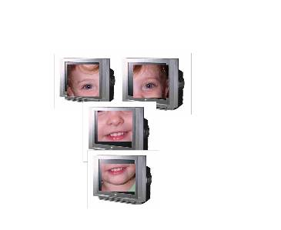 | Visitor sits on a stool with adjustable height and lines his nose up to a mark.  4 cameras (1 for each eye, 1 for the nose, 1 for the mouth) put images of the face on 4 video monitors, which are stacked in such a way that it looks like a 6-foot-tall face.
 | 3 strips of double-sided mirrors are placed vertically and spaced apart in a display between where 2 Visitors sit facing each other. This combines 2 faces together – my forehead, your eyes, my nose, your mouth, my chin.  This is very inexpensive and is already at another science center. It I just fun (a complement to the mirror set up you already have).
  Laced faces | 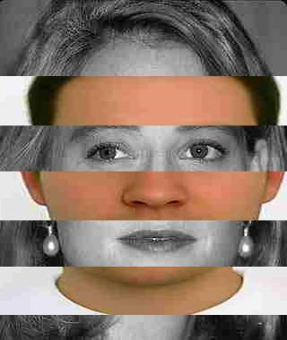
The fascinating “More or Less Attractive” test  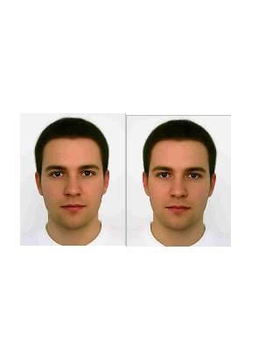 | Most people think their mirror image is more attractive than their real image. And most friends/family think the real image is more attractive.  Apparently, it's all what you're used to.  Visitor looks into camera. Camera makes sound implying that it took 2 different shots right in a row, but it really only took one. A real image and a mirror image of Visitor are then shown on two monitors. (The monitors are not side by side each other because this would make it too easy to tell that one was just a mirror image of the other.) Visitor and her friends are directed to walk to the one that is more attractive.  Most of the time Visitor will chose mirror image and the friends will choose real image.  Discussion Questions for Visitors to discuss amongst themselves:  - What is the Lesson here?  - How does that apply to other things?

Ideas that other places are already doing that McWane could adopt:

Rat Basketball | This is a very popular daily exhibit that The Discovery Place in Charlotte has. It teaches the concept of "positive reward conditioning" and is very entertaining, with pom-pom’s being passed around, a "Rat-feree" and volunteer score-keepers.

Scientist Cards | When you first go into the Holocaust Museum, you get to choose a card. The cards are shaped like greeting cards/Christmas cards, and are only divided into "men" stack and "women" stack. They are of an individual person affected by the holocaust, and there were many multiple people. Each card included a photo and details about the person's life before, during and after the war. I really enjoyed looking at all the different ones.  Do this with lesser-known scientists, dead and alive. Have a childhood photo and adult photo of the scientist. This will help Visitors immediately identify with scientists and show the multitude of different people who are scientists.  Or show real working (local?) scientists in a baseball-card like format.  Have their current and childhood photo and interesting stuff about their life and work  Each child gets to pick just one (that way they'll value it more). They'll usually pick one that looks like them or has their name.  A complete deck of these cards -- in greeting card (or pared-down to playing card deck format) available for sale in gift shop

Talking Points:

- Interested in a career change, your industry of exhibit design

- Have diverse background – left and right brain skills. -- I win Halloween Costumes prizes and got 800 on my math SATs, I’ve sold advice, produced TV shows and created computer games.

- therefore…..I can take prototype through stages and design good solid exhibits.

- I developed these new ambitions because of my passion over an idea called TCZ
- Slogan of TCZ
- Brief description of TCZ
- To d a business of my own, I need some experience.

- I could have a relationship with McWane in 2 ways.

- 4 clusters to give example of ideas I can bring. These are mostly created after visiting The McWane Center this weekend.

